Chapter 7
Consumers, Producers, and the Efficiency of Markets
MULTIPLE CHOICE
1. Welfare economics is the study of
a. the well-being of less fortunate people.
b. welfare programs in the United States.
c. the effect of income redistribution on work effort.
d. how the allocation of resources affects economic well-being.
ANSWER: d. how the allocation of resources affects economic well-being.
TYPE: M DIFFICULTY: 1
2. The study of how the allocation of resources affects economic well-being is called
a. consumer economics.
b. macroeconomics.
c. welfare economics.
d. supply-side economics.
ANSWER: c. welfare economics.
TYPE: M DIFFICULTY: 1
3. With respect to welfare economics, the equilibrium price of a product is considered to be the best price because it
a. maximizes total revenue to firms and total utility to buyers.
b. maximizes the total welfare of buyers and sellers.
c. minimizes costs and maximizes profits of sellers.
d. minimizes the level of welfare payments to those who no longer live below the poverty line.
ANSWER: b. it maximizes the total welfare of buyers and sellers.
TYPE: M DIFFICULTY: 2
4. Positive analysis refers to what
a. is.
b. should be.
c. could be.
d. is politically correct.
ANSWER: a. is.
TYPE: M DIFFICULTY: 1
5. Normative analysis refers to what
a. is.
b. should be.
c. maximizes efficiency.
d. is politically correct.
ANSWER: b. should be.
TYPE: M DIFFICULTY: 1
6. The equilibrium of supply and demand in a market
a. maximizes the profits of producers.
b. can only be achieved with government intervention.
c. produces both an efficient and equitable market outcome.
d. maximizes the total benefits received by buyers and sellers.
ANSWER: d. maximizes the total benefits received by buyers and sellers.
TYPE: M DIFFICULTY: 2
7. The particular price that results in quantity supplied being equal to quantity demanded is the best price because it
a. maximizes costs of the seller.
b. maximizes the profit of buyers.
c. maximizes the total welfare of buyers and sellers.
d. minimizes the expenditure of buyers.
ANSWER: c. maximizes the total welfare of buyers and sellers.
TYPE: M DIFFICULTY: 2
8. Suppose that Larry, Moe and Curly are bidding in an auction for a mint-condition video of Charlie Chaplin’s first movie. Each has in mind a maximum amount that he will bid. This maximum is called
a. a resistance price.
b. willingness to pay.
c. consumer surplus.
d. producer surplus.
ANSWER: b. willingness to pay.
TYPE: M SECTION: 1 DIFFICULTY: 1
9. Willingness to pay measures the
a. amount a buyer is willing to pay for a good minus the amount the buyer actually pays for it.
b. amount a seller actually receives for a good minus the minimum amount the seller is willing to accept.
c. maximum amount a buyer is willing to pay minus the minimum amount a seller is willing to accept.
d. maximum amount that a buyer will pay for a good.
ANSWER: d. maximum amount that a buyer will pay for a good.
TYPE: M SECTION: 1 DIFFICULTY: 2
10. Consumer surplus is
a. a buyer’s willingness to pay minus the price.
b. a buyer’s willingness to pay plus the price.
c. the price of the product minus the buyer’s willingness to pay.
d. when the buyer’s willingness to pay and the price of the product are equal.
ANSWER: a. a buyer’s willingness to pay minus the price.
TYPE: M SECTION: 1 DIFFICULTY: 2
11. Consumer surplus measures
a. the amount of a product a consumer can buy at a price below equilibrium price.
b. the difference between the amount a consumer has to pay and the amount the consumer was willing to pay.
c. the number of consumers who are excluded from a market because of scarcity.
d. how much a buyer values a good.
ANSWER: b. the difference between the amount a consumer has to pay and the amount the consumer was willing to pay.
TYPE: M SECTION: 1 DIFFICULTY: 2
12. A consumer’s willingness to pay measures
a. the cost of a good to the buyer.
b. how much a buyer values a good.
c. how much a buyer has to pay to receive a good.
d. how much a seller receives from the sale of a good.
ANSWER: b. how much a buyer values a good.
TYPE: M SECTION: 1 DIFFICULTY: 2
13. If a consumer is willing and able to pay $15.00 for a particular good but the price of the good is $17.00, then the
a. consumer would have consumer surplus of $2.00.
b. consumer would increase his/her willingness and ability to pay by earning more.
c. consumer would not purchase the good and would not have any consumer surplus.
d. market must not be a perfectly competitive market.
ANSWER: c. consumer would not purchase the good and would not have any consumer surplus.
TYPE: M SECTION: 1 DIFFICULTY: 2
14. If a consumer is willing and able to pay $20.00 for a particular good but only has to pay $14.00, the consumer surplus is
a. $6.00.
b. $14.00.
c. $20.00.
d. $34.00.
ANSWER: a. $6.00.
TYPE: M SECTION: 1 DIFFICULTY: 2
15. Belva is willing to pay $65.00 for a pair of shoes for a formal dance. She finds a pair at her favorite outlet shoe store for $48.00. Belva’s consumer surplus is
a. $17.
b. $31.
c. $48.
d. $65.
ANSWER: a. $17.
TYPE: M SECTION: 1 DIFFICULTY:1
16. If Brock is willing to pay $400 for a new suit, but is able to buy the suit for $350, his consumer surplus is
a. $50.
b. $150.
c. $350.
d. $400.
ANSWER: a. $50.
TYPE: M SECTION: 1 DIFFICULTY: 1
17. Suppose Lauren, Leslie and Lydia all purchase bulletin boards for their rooms for $15 each. Lauren’s willingness to pay was $35, Leslie’s willingness to pay was $25, and Lydia’s willingness to pay was $30. Total consumer surplus for these three would be
a. $15.
b. $25.
c. $35.
d. $45.
ANSWER: d. $45.
TYPE: M SECTION: 1 DIFFICULTY: 2
18. Suppose Lauren, Leslie and Lydia all purchase bulletin boards for their rooms for $15 each. Lauren’s willingness to pay was $35, Leslie’s willingness to pay was $25, and Lydia’s willingness to pay was $30. Which of the three receives the most consumer surplus from her purchase?
a. Lauren
b. Leslie
c. Lydia
d. They each received the same consumer surplus since they each paid the same for the bulletin board.
ANSWER: a. Lauren
TYPE: M SECTION: 1 DIFFICULTY: 2
19. Shannon buys a new CD player for her car for $135. She receives consumer surplus of $25 on her purchase. Her willingness to pay is
a. $25.
b. $110.
c. $135.
d. $160.
ANSWER: d. $160.
TYPE: M SECTION: 1 DIFFICULTY: 2

BUYER | WILLINGNESS TO PAY
MIKE | $50.00
SANDY | $30.00
JONATHAN | $20.00
HALEY | $10.00

20. If the table represents the willingness to pay of 4 buyers and the price of the product is $15, then who would be willing to purchase the product?
a. Mike
b. Mike and Sandy
c. Mike, Sandy, and Jonathan
d. Mike, Sandy, Jonathan, and Haley
ANSWER: c. Mike, Sandy, and Jonathan
TYPE: M SECTION: 1 DIFFICULTY: 2
21. Janine would be willing to pay $50 to see Les Misérables, but buys a ticket for only $30. Janine values the performance at
a. $20.
b. $30.
c. $50.
d. $80.
ANSWER: c. $50.
TYPE: M SECTION: 1 DIFFICULTY: 1
22. Chad is willing to pay $4.00 to get his second cup of morning latté. He finds a vendor selling latté for $3.75. Chad’s consumer surplus is
a. $0.25.
b. $0.50.
c. $3.75.
d. $4.00.
ANSWER: a. $0.25.
TYPE: M SECTION: 1 DIFFICULTY: 1
23. Denise values a stainless steel dishwasher for her new house at $500, but buys it for $350. Denise’s willingness to pay is
a. $150.
b. $350.
c. $500.
d. $850.
ANSWER: c. $500.
TYPE: M SECTION: 1 DIFFICULTY: 2
24. Denise values a stainless steel dishwasher for her new house at $500. The actual price of the dishwasher is $650. Denise
a. buys the dishwasher and receives a consumer surplus of $150.
b. buys the dishwasher and receives a consumer surplus of $500.
c. does not buy the dishwasher because her willingness to pay is greater than the price.
d. does not buy the dishwasher because her willingness to pay is less than the price.
ANSWER: d. does not buy the dishwasher because her willingness to pay is less than the price.
TYPE: M SECTION: 1 DIFFICULTY: 2
25. Amy buys a new dog for $150. She receives consumer surplus of $100 on her purchase. Her willingness to pay is
a. $50.
b. $100.
c. $150.
d. $250.
ANSWER: d. $250.
TYPE: M SECTION: 1 DIFFICULTY: 2
26. Ray buys a new tractor for $118,000. He receives consumer surplus of $13,000 on his purchase. Ray’s willingness to pay is
a. $13,000.
b. $105,000.
c. $118,000.
d. $131,000.
ANSWER: d. $131,000.
TYPE: M KEY1: E SECTION: 1 OBJECTIVE: 2 RANDOM: Y
27. Jeff decides that he would pay as much as $3,000 for a new laptop computer. He buys the computer and realizes consumer surplus of $700. How much did Jeff pay for his computer?
a. $700
b. $2,300
c. $3,000
d. $3,700
ANSWER: b. $2,300
TYPE: M SECTION: 1 DIFFICULTY: 2
28. Cameron visits a sporting goods store to buy a new set of golf clubs. He is willing to pay $750 for the clubs, but buys them on sale for $575. Cameron’s consumer surplus from the purchase is
a. $175.
b. $575.
c. $750.
d. $1,325.
ANSWER: a. $175.
TYPE: M SECTION: 1 DIFFICULTY: 1
29. Nathan buys a new sound system for his dorm room for $500. He receives consumer surplus of $400 from the purchase. How much does Nathan value his sound system?
a. $100
b. $400
c. $500
d. $900
ANSWER: d. $900
TYPE: M SECTION: 1 DIFFICULTY: 2
30. Consumer surplus is the
a. quantity of a good consumers get free.
b. amount a consumer has to pay less the amount the consumer was willing to pay.
c. amount a consumer is willing to pay less the amount the consumer actually pays.
d. total value of a good to a consumer.
ANSWER: c. amount a consumer is willing to pay less the amount the consumer actually pays.
TYPE: M SECTION: 1 DIFFICULTY: 1
31. If the price a consumer pays for a product is equal to a consumer’s willingness to pay, then the consumer surplus of that purchase would be
a. zero.
b. negative and the consumer would not purchase the product.
c. positive and therefore the consumer would purchase the product.
d. There is not enough information given to answer this question.
ANSWER: a. zero.
TYPE: M SECTION: 1 DIFFICULTY: 2
32. Suppose there is an early freeze in California that ruins the lemon crop. What happens to consumer surplus in the market for lemons?
a. It increases.
b. It decreases.
c. It is not affected by this change in market forces.
d. It increases very briefly then decreases.
ANSWER: b. It decreases.
TYPE: M SECTION: 1 DIFFICULTY: 3
33. If you pay a price exactly equal to your willingness to pay, then
a. your consumer surplus is negative.
b. your willingness to pay is less than your consumer surplus.
c. your consumer surplus is zero.
d. you place little value on the good.
ANSWER: c. your consumer surplus is zero.
TYPE: M SECTION: 1 DIFFICULTY: 2
34. A demand curve reflects each of the following EXCEPT the
a. willingness to pay of all buyers in the market.
b. value each buyer in the market places on the good.
c. highest price buyers are willing to pay for each quantity.
d. ability of buyers to obtain the quantity they desire.
ANSWER: d. ability of buyers to obtain the quantity they desire.
TYPE: M SECTION: 1 DIFFICULTY: 2
35. A demand curve measures
a. a buyer’s willingness to pay.
b. the actual price a buyer must pay to get the product.
c. the difference between a buyer’s willingness to pay and the actual price of the product.
d. All of the above are correct.
ANSWER: a. a buyer’s willingness to pay.
TYPE: M SECTION: 1 DIFFICULTY: 1
This table refers to five possible buyers’ willingness to pay for a case of Vanilla Coke.

BUYER | WILLINGNESS TO PAY
DAVID | $8.50
LAURA | $7.00
MEGAN | $5.50
MALLORY | $4.00
AUDREY | $3.50

36. According to the table shown, if the market price is $5.50, the consumer surplus in the market will be
a. $3.00.
b. $4.50.
c. $15.50.
d. $21.00.
ANSWER: b. $4.50.
TYPE: M SECTION: 1 DIFFICULTY: 2
37. According to the table shown, if the price of Vanilla Coke is $6.90, who will purchase the good?
a. All five would purchase Vanilla Coke, just in different amounts.
b. Megan, Mallory and Audrey
c. David, Laura and Megan
d. David and Laura
ANSWER: d. David and Laura
TYPE: M SECTION: 1 DIFFICULTY: 2
38. According to the table shown, which of the following is NOT true?
a. At a price of $9.00, no buyer is willing to purchase Vanilla Coke.
b. The table shows the willingness to pay of the marginal buyer.
c. When the price is $3.50, each person would receive consumer surplus.
d. At a price of $4.00, total consumer surplus in the market will be $9.00.
ANSWER: c. When the price is $3.50, each person would receive consumer surplus.
TYPE: M SECTION: 1 DIFFICULTY: 2
39. Consumer surplus equals the
a. Value to buyers – Amount paid by buyers.
b. Amount received by sellers – Costs of sellers.
c. Value to buyers – Costs of sellers.
d. Value to buyers – Amount paid by buyers + Amount received by sellers – Costs of sellers.
ANSWER: a. Value to buyers – Amount paid by buyers.
TYPE: M SECTION: 1 DIFFICULTY: 2
40. The area below a demand curve and above the price measures
a. producer surplus.
b. total surplus.
c. consumer surplus.
d. willingness to pay.
ANSWER: c. consumer surplus.
TYPE: M SECTION: 1 DIFFICULTY: 1
41. On a graph, consumer surplus would be the area
a. between the demand and supply curves.
b. below the demand curve and above price.
c. below the price and above the supply curve.
d. below the demand curve to the right of equilibrium price.
ANSWER: b. below the demand curve and above price.
TYPE: M SECTION: 1 DIFFICULTY: 2
42. Consumer surplus in a market is the
a. area below the demand curve and above the price.
b. distance from the demand curve to the horizontal axis.
c. distance from the demand curve to the vertical axis.
d. area below the demand curve and above the horizontal axis.
ANSWER: a. area below the demand curve and above the price.
TYPE: M SECTION: 1 DIFFICULTY: 2
43. If the cost of producing sofas decreases, consumer surplus will
a. increase, then decrease.
b. decrease.
c. remain constant.
d. increase.
ANSWER: d. increase.
TYPE: M SECTION: 1 DIFFICULTY: 3
44. What happens to consumer surplus if the price of a good increases?
a. It increases.
b. It decreases.
c. It is unchanged.
d. It may increase, decrease, or remain unchanged.
ANSWER: b. It decreases.
TYPE: M SECTION: 1 DIFFICULTY: 2
45. When technology improves in the ice cream industry, consumer surplus will
a. increase.
b. decrease.
c. not change, since technology affects suppliers and not consumers..
d. increase, then decrease.
ANSWER: a. increase.
TYPE: M SECTION: 1 DIFFICULTY: 3
46. If the price of oak lumber increases, what happens to consumer surplus in the market for oak cabinets?
a. It increases.
b. It decreases.
c. It will not change consumer surplus, but it will change producer surplus.
d. It will increase, then decrease.
ANSWER: b. It decreases.
TYPE: M SECTION: 1 DIFFICULTY: 3
47. If the cost of producing chocolate decreases, consumer surplus
a. decreases.
b. increases.
c. remains constant.
d. decreases, then increases.
ANSWER: b. increases.
TYPE: M SECTION: 1 DIFFICULTY: 3
48. Other things equal, if the price of a good falls, the consumer surplus
a. decreases.
b. is unchanged.
c. increases.
d. may increase, decrease, or remain unchanged.
ANSWER: c. increases.
TYPE: M SECTION: 1 DIFFICULTY: 2
49. The height of a demand curve measures
a. the value buyers place on a good.
b. a buyer’s willingness to pay.
c. the price buyers must pay for the good.
d. Both a and b are correct.
e. All of the above are correct.
ANSWER: d. Both a and b are correct.

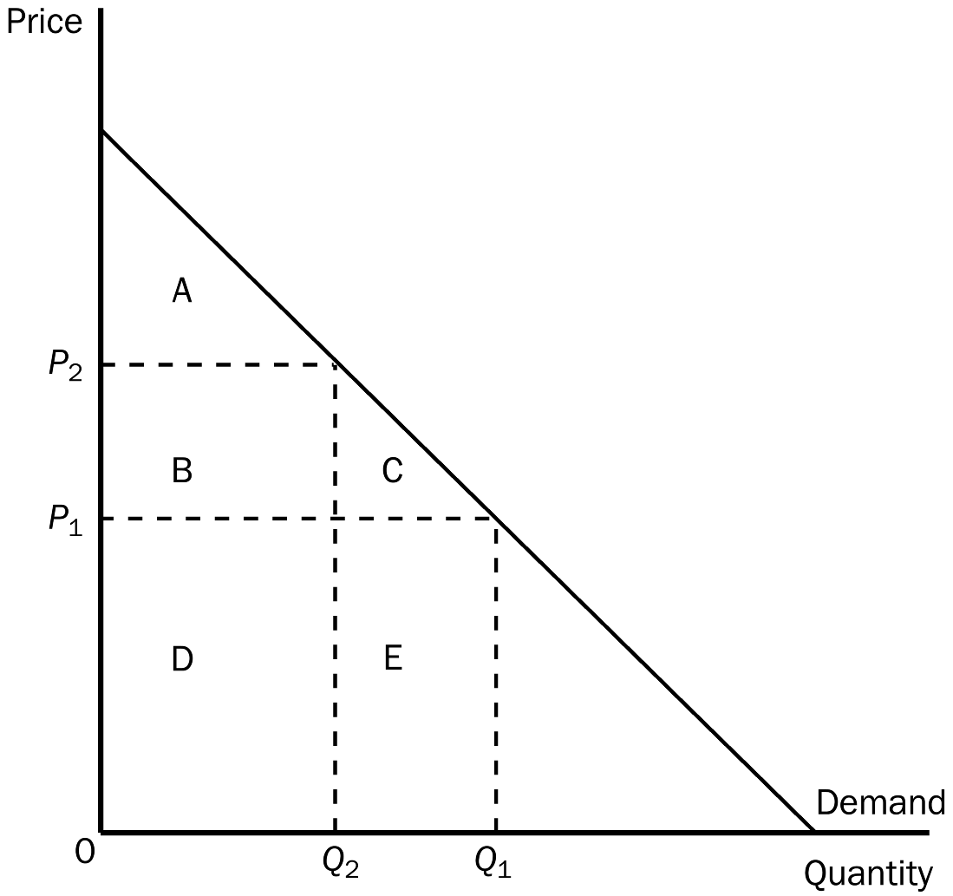
50. According to the graph shown, when the price is P₁, consumer surplus is
a. A.
b. A + B.
c. A + B + C.
d. A + B + D.
ANSWER: c. A + B + C.
TYPE: M SECTION: 1 DIFFICULTY: 2
51. According to the graph shown, at the price of P₂, consumer surplus is
a. A.
b. B.
c. A + B.
d. A + B + C.
ANSWER: a. A.
TYPE: M SECTION: 1 DIFFICULTY: 2
52. According to the graph shown, when the price rises from P₁ to P₂, consumer surplus
a. increases by an amount equal to A.
b. decreases by an amount equal to B + C.
c. increases by an amount equal to B + C.
d. decreases by an amount equal to C.
ANSWER: b. decreases by an amount equal to B + C.
TYPE: M SECTION: 1 DIFFICULTY: 3
53. According to the graph shown, area C represents
a. the decrease in consumer surplus that results from a downward-sloping demand curve.
b. consumer surplus to new consumers who enter the market when the price falls from P₂ to P₁ .
c. an increase in producer surplus when quantity sold increases from Q₂ to Q₁ .
d. a decrease in consumer surplus to each consumer in the market.
ANSWER: b. consumer surplus to new consumers who enter the market when the price falls from P₂ to P₁ .
TYPE: M SECTION: 1 DIFFICULTY: 3
54. According to the graph shown, when the price rises from P₁ to P₂, which would NOT be true?
a. The buyers who still buy the good are worse off because they now pay more.
b. Some buyers leave the market because they are not willing to buy the good at the higher price.
c. The total value of what is now purchased by buyers is actually higher.
d. Consumer surplus in the market falls.
ANSWER: c. The total value of what is now purchased to buyers is actually higher.
TYPE: M SECTION: 1 DIFFICULTY: 3
55. Which of the following is NOT true when the price of a good or service falls?
a. Buyers who were already buying the good or service are better off.
b. Some new buyers, who are now willing to buy, enter the market.
c. The total consumer surplus in the market increases.
d. The total value of what is purchased remains unchanged.
ANSWER: d. The total value of what is purchased remains unchanged.
TYPE: M SECTION: 1 DIFFICULTY: 2
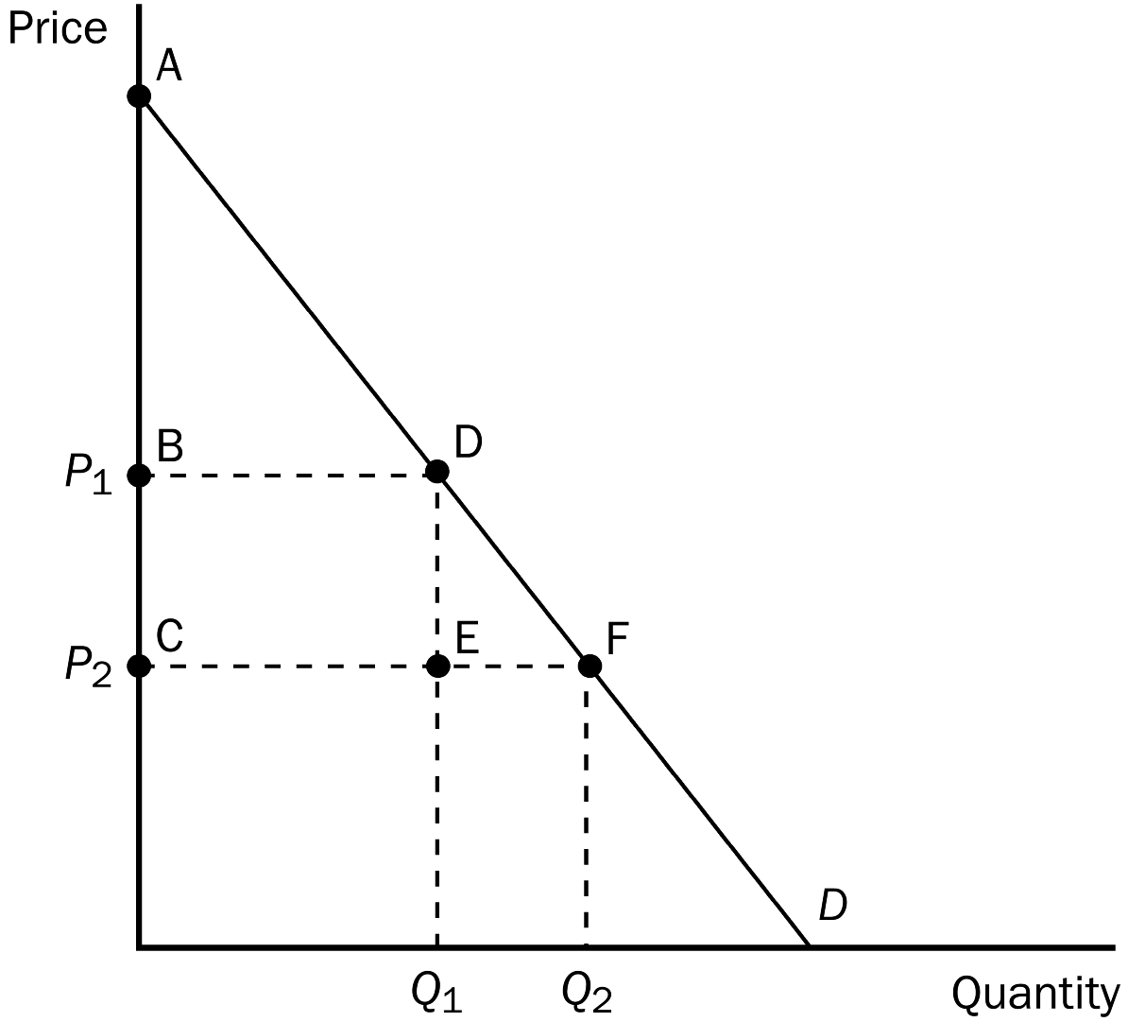
56. Given the graph, which area represents consumer surplus at a price of P₁?
a. ABD
b. ACF
c. BCDE
d. DEF
e. BCFD
ANSWER: a. ABD
TYPE: M SECTION: 1 DIFFICULTY: 2
57. Given the graph, which area represents consumer surplus at a price of P₂?
a. ABD
b. ACF
c. BCDE
d. DEF
e. BCFD
ANSWER: b. ACF
TYPE: M SECTION: 1 DIFFICULTY: 2
58. Given the graph, which area represents the increase in consumer surplus when the price falls from P₁ to P₂?
a. ABD
b. ACF
c. BCDE
d. DEF
e. BCFD
ANSWER: e. BCFD
TYPE: M SECTION: 1 DIFFICULTY: 3
59. Given the graph, when the price falls from P₁ to P₂, which area represents the increase in consumer surplus to existing buyers?
a. ABD
b. ACF
c. BCED
d. DEF
e. BCFD
ANSWER: c. BCED
TYPE: M SECTION: 1 DIFFICULTY: 3
60. Given the graph, when the price falls from P₁ to P₂, which area represents the increase in consumer surplus to new buyers entering the market?
a. ABD
b. ACF
c. BCDE
d. DEF
e. BCFD
ANSWER: d. DEF
TYPE: M SECTION: 1 DIFFICULTY: 3
61. Dallas buys strawberries, and would be willing to pay more than he now has to pay. Suppose that Dallas has a change in his tastes such that he values strawberries more than before. If the market price is the same as before, then
a. Dallas’s consumer surplus would be unaffected.
b. Dallas’s consumer surplus would increase.
c. Dallas’s consumer surplus would decrease.
d. Dallas would be wise to buy fewer strawberries than before.
ANSWER: b. Dallas’s consumer surplus would increase.
TYPE: M SECTION: 1 DIFFICULTY: 3
62. In most markets, consumer surplus
a. reflects economic well-being.
b. reflects the total value that buyers place on goods or services.
c. reflects the benefit to buyers mandated by government.
d. All of the above are correct.
ANSWER: a. reflects economic well-being.
TYPE: M SECTION: 1 DIFFICULTY: 2
63. Out-of-pocket expenses plus the value of the seller’s own resources used in production are considered to be
a. the seller’s total revenue.
b. the seller’s consumer surplus.
c. producer surplus.
d. the cost of production.
ANSWER: d. the cost of production.
TYPE: M SECTION: 2 DIFFICULTY: 2
64. Cost is a measure of the
a. seller’s willingness to sell.
b. seller’s producer surplus.
c. producer shortage.
d. seller’s willingness to buy.
ANSWER: a. seller’s willingness to sell.
TYPE: M SECTION: 2 DIFFICULTY: 1
65. Cost refers to a seller’s
a. producer surplus.
b. opportunity cost.
c. consumer surplus.
d. willingness to buy.
ANSWER: b. opportunity cost.
TYPE: M SECTION: 2 DIFFICULTY: 2
66. A supply curve can be used to measure producer surplus because it reflects
a. the actions of sellers.
b. quantity supplied.
c. sellers’ costs.
d. the amount that will be purchased by consumers in the market.
ANSWER: c. sellers’ costs.
TYPE: M SECTION: 2 DIFFICULTY: 2
67. A seller would be willing to sell a product ONLY IF the price received is
a. less than the cost of production.
b. at least as great as the cost of production.
c. equal to the cost of production.
d. at least double the cost of production.
ANSWER: b. at least as great as the cost of production.
TYPE: M SECTION: 2 DIFFICULTY: 2
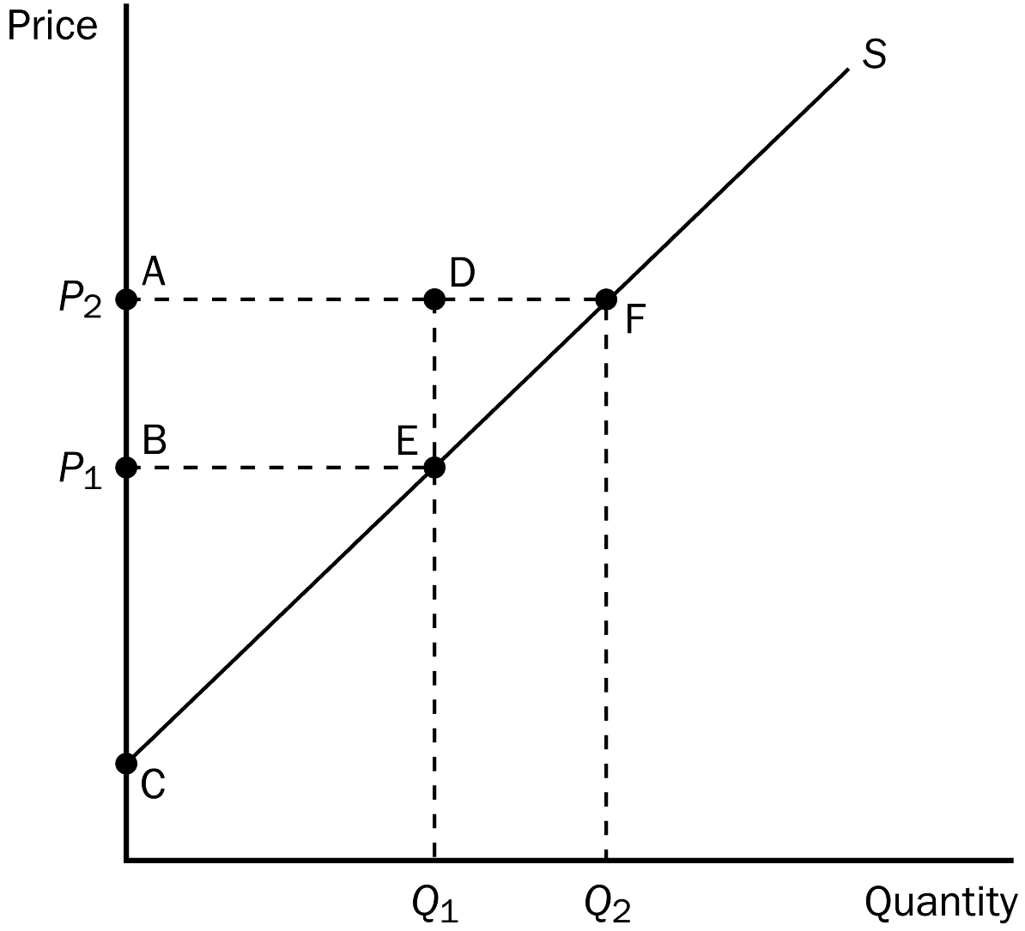
68. According to the graph, which area represents producer surplus at a price of P₁?
a. BCE
b. ACF
c. ABED
d. DEF
e. AFEB
ANSWER: a. BCE
TYPE: M SECTION: 2 DIFFICULTY: 2
69. According to the graph, which area represents producer surplus at a price of P₂?
a. BCE
b. ACF
c. ABED
d. DEF
e. AFEB
ANSWER: b. ACF
TYPE: M SECTION: 2 DIFFICULTY: 2
70. According to the graph, which area represents the increase in producer surplus when the price rises from P₁ to P₂?
a. BCE
b. ACF
c. ABED
d. DEF
e. AFEB
ANSWER: e. AFEB
TYPE: M SECTION: 2 DIFFICULTY: 2
71. According to the graph, when the price rises from P₁ to P₂, which area represents the increase in producer surplus to existing producers?
a. BCE
b. ACF
c. ABED
d. DEF
e. AFEB
ANSWER: c. ABED
TYPE: M SECTION: 2 DIFFICULTY: 2
72. According to the graph, which area represents the increase in producer surplus when the price rises from P₁ to P₂ due to new producers entering the market?
a. BCE
b. ACF
c. ABED
d. DEF
e. AFEB
ANSWER: d. DEF
TYPE: M SECTION: 2 DIFFICULTY: 2
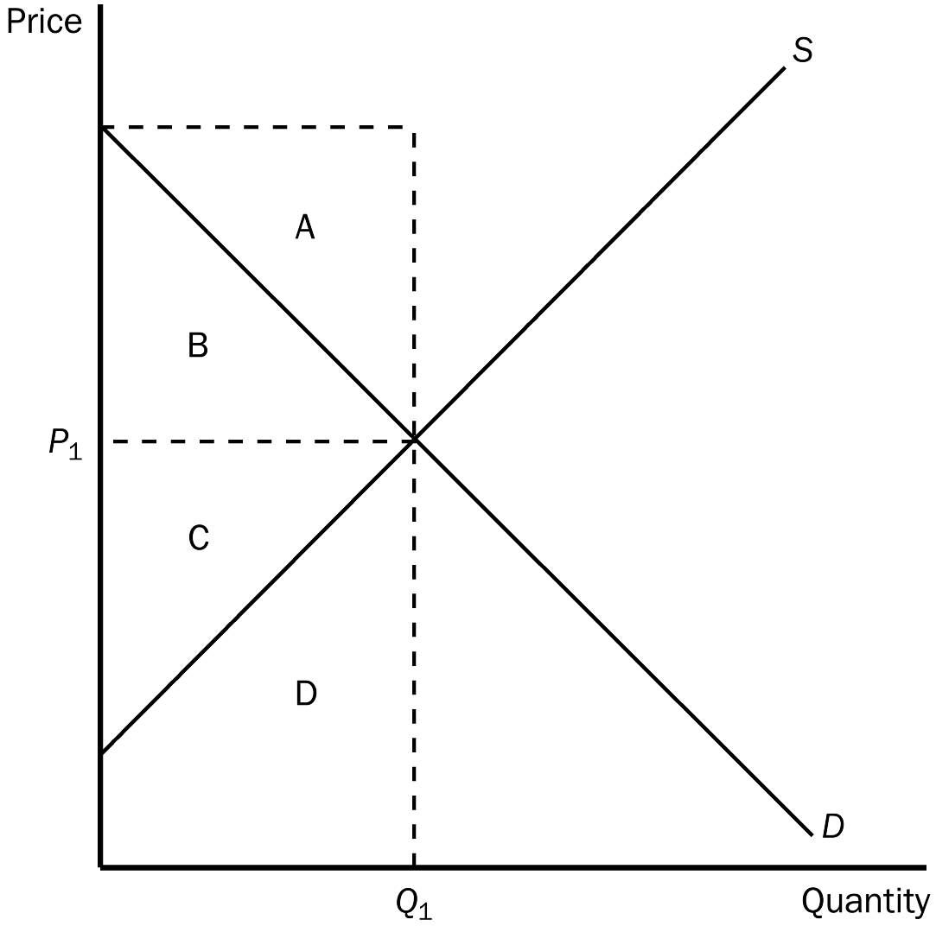
73. According to the graph shown, what area represents consumer surplus when the price is P₁?
a. A
b. B
c. C
d. D
ANSWER: b. B
TYPE: M SECTION: 3 DIFFICULTY: 2
74. According to the graph shown, what area represents producer surplus when the price is P₁?
a. A
b. B
c. C
d. D
ANSWER: c. C
TYPE: M SECTION: 3 DIFFICULTY: 2
75. According to the graph shown, what area represents total surplus in the market when the price is P₁?
a. A + B
b. B + C
c. C + D
d. A + B + C + D
ANSWER: b. B + C
TYPE: M SECTION: 3 DIFFICULTY: 2
76. Suppose the demand for nachos increases. What will happen to producer surplus in the market for nachos?
a. It increases.
b. It decreases.
c. It is unaffected by this change in market forces.
d. It decreases briefly, then increases.
ANSWER: a. It increases.
TYPE: M SECTION: 3 DIFFICULTY: 2
77. If demand decreases, the price of a product, as well as producer surplus,
a. increases.
b. decreases.
c. remains the same.
d. may increase, decrease, or remain the same.
ANSWER: b. decreases.
TYPE: M SECTION: 3 DIFFICULTY: 2
78. The Surgeon General announces that eating chocolate increases tooth decay. As a result, the equilibrium market price of chocolate
a. increases, and producer surplus increases.
b. increases, and producer surplus decreases.
c. decreases, and producer surplus decreases.
d. decreases, and producer surplus increases.
ANSWER: c. decreases, and producer surplus decreases.
TYPE: M SECTION: 3 DIFFICULTY: 3
79. Suppose consumer income increases. If grass seed is a normal good, the equilibrium price of grass seed will
a. decrease, and producer surplus in the industry will decrease.
b. increase, and producer surplus in the industry will increase.
c. decrease, and producer surplus in the industry will increase.
d. increase, and producer surplus in the industry will decrease.
ANSWER: b. increase, and producer surplus in the industry will increase.
TYPE: M SECTION: 3 DIFFICULTY: 3
80. Producer surplus equals
a. Value to buyers – Amount paid by buyers.
b. Amount received by sellers – Costs of sellers.
c. Value to buyers – Costs of sellers.
d. Value to buyers – Amount paid by buyers + Amount received by sellers – Costs of sellers.
ANSWER: b. Amount received by sellers – Costs of sellers.
TYPE: M SECTION: 2 DIFFICULTY: 3
81. Which of the following would NOT be true concerning a seller’s cost?
a. A seller would be eager to sell her product at a price higher than her cost.
b. A seller would refuse to sell her product at a price lower than her cost.
c. A seller would be indifferent about selling her product at a price equal to her cost.
d. Since sellers cannot set the price for their product, they must be willing to sell their product at any price.
ANSWER: d. Since sellers cannot set the price for their product, they must be willing to sell their product at any price.
TYPE: M SECTION: 2 DIFFICULTY: 2
82. Producer surplus is the
a. area under the supply curve to the left of the amount sold.
b. amount a seller is paid less the cost of production.
c. amount represented by the area under the supply curve.
d. cost to sellers of participating in a market.
ANSWER: b. amount a seller is paid less the cost of production.
TYPE: M SECTION: 2 DIFFICULTY: 2
83. Producer surplus measures all of the following EXCEPT the
a. amount sellers receive above the minimum they would accept.
b. benefit to sellers of participating in a market.
c. amount sellers are paid less the amount they were willing to accept.
d. total value of a good to sellers.
ANSWER: d. total value of a good to sellers.
TYPE: M SECTION: 2 DIFFICULTY: 2
84. Producer surplus is the area
a. under the supply curve.
b. between the supply and demand curves.
c. below the price and above the supply curve.
d. under the demand curve, and above the price.
ANSWER: c. below the price and above the supply curve.
TYPE: M SECTION: 2 DIFFICULTY: 1

SELLER | COST
DALE | $1,500
JILL | $1,200
DENISE | $1,000
CATHERINE | $750
JACKSON | $500

The table represents the costs of five possible sellers.
85. According to the table shown, if the market price is $1,000, the producer surplus in the market would be
a. $700.
b. $750.
c. $2,250.
d. $3,700.
ANSWER: b. $750.
TYPE: M SECTION: 2 DIFFICULTY: 2
86. According to the table shown, if the market price is $1,000, the total cost in the market would be
a. $3,700.
b. $2,700.
c. $2,250.
d. $1,500.
ANSWER: c. $2,250.
TYPE: M SECTION: 2 DIFFICULTY: 2
87. According to the table shown, if the price is $1,000, Jackson’s producer surplus would be
a. $1,000.
b. $750.
c. $500.
d. $250.
ANSWER: c. $500.
TYPE: M SECTION: 2 DIFFICULTY: 2
88. According to the table shown, if the price is $1,100, who would be willing to supply the product?
a. Dale and Jill
b. Dale, Jill and Denise
c. Denise, Catherine and Jackson
d. Catherine and Jackson
ANSWER: c. Denise, Catherine and Jackson
TYPE: M SECTION: 2 DIFFICULTY: 2
89. The marginal seller is the seller who
a. cannot compete with the other sellers in the market.
b. would leave the market first if the price were any lower.
c. can produce at the lowest cost.
d. has the greatest producer surplus.
ANSWER: b. would leave the market first if the price were any lower.
TYPE: M SECTION: 2 DIFFICULTY: 1

90. According to the graph shown, when the price is P₂, producer surplus is
a. A.
b. A + C.
c. A + B + C.
d. D + E.
ANSWER: c. A + B + C.
TYPE: M SECTION: 2 DIFFICULTY: 2
91. According to the graph shown, at the price of P₁, producer surplus is
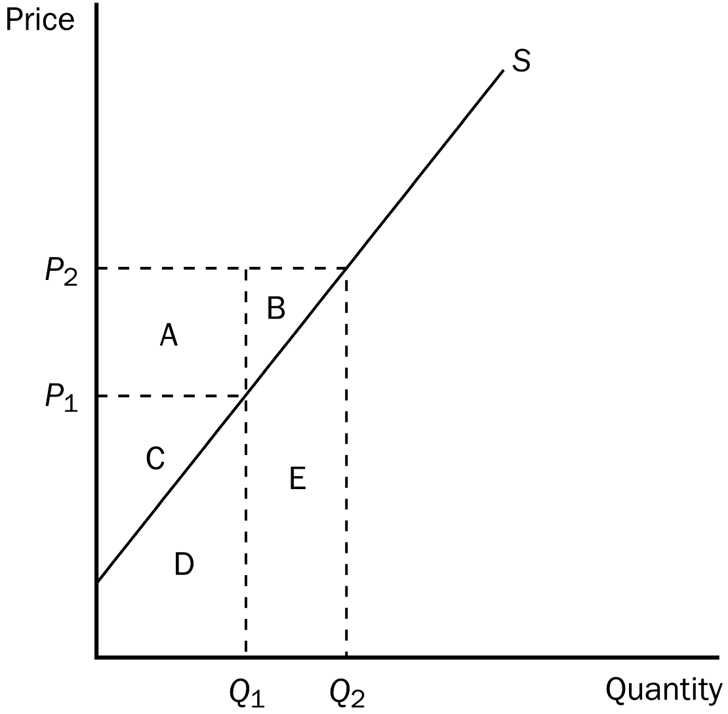
a. A.
b. A + B.
c. C.
d. A + B + C.
ANSWER: c. C.
TYPE: M SECTION: 2 DIFFICULTY: 2
92. According to the graph shown, when the price falls from P₂ to P₁, producer surplus
a. decreases by an amount equal to A.
b. decreases by an amount equal to A + C.
c. decreases by an amount equal to A + B.
d. increases by an amount equal to A + B.
ANSWER: c. decreases by an amount equal to A + B.
TYPE: M SECTION: 2 DIFFICULTY: 2
93. According to the graph shown, area B represents
a. producer surplus to new producers entering the market as the result of price rising from P₁ to P₂.
b. the increase in consumer surplus that results from an upward-sloping supply curve.
c. an increase in producer surplus to every producer in the market.
d. an increase in total surplus when sellers are willing and able to increase supply from Q₁ to Q₂.
ANSWER: a. producer surplus to new producers entering the market as the result of price rising from P₁ to P₂.
TYPE: M SECTION: 2 DIFFICULTY: 3
94. According to the graph shown, when the price falls from P₂ to P₁, which of the following would NOT be true?
a. The sellers who still sell the good are worse off because they now receive less.
b. Some sellers leave the market because they are not willing to sell the good at the lower price.
c. The total cost of what is now sold by sellers is actually higher.
d. Producer surplus would fall by area A + B.
ANSWER: c. The total cost of what is now sold by sellers is actually higher.
TYPE: M SECTION: 2 DIFFICULTY: 3
95. According to the graph shown, area A represents
a. producer surplus to new producers entering the market as the result of price rising from P₁ to P₂.
b. the increase in consumer surplus that results from an upward-sloping supply curve.
c. an increase in total surplus when sellers are willing and able to increase supply from Q₁ to Q₂.
d. the increase in producer surplus to those producers already in the market when price rises from P₁ to P₂ .
ANSWER: d. the increase in producer surplus to those producers already in the market when price rises from P₁ to P₂ .
TYPE: M SECTION: 2 DIFFICULTY: 3
96. One thing economists believe was instrumental in the survival of the Pilgrims after three years of starvation was
a. the assignment of property rights which increased productivity.
b. a mild autumn, which provided an extended growing season.
c. the increased opportunity to trade with the natives for food.
d. a stronger sense of community which improved cooperation among the survivors.
ANSWER: a. the assignment of property rights which increased productivity.
TYPE: M SECTION: 2 DIFFICULTY: 2
97. Producer surplus measures the
a. well-being of society as a whole.
b. well-being of sellers.
c. well-being of buyers and sellers.
d. loss to sellers.
ANSWER: b. well-being of sellers.
TYPE: M SECTION: 2 DIFFICULTY: 2
98. Producer surplus measures
a. the well-being of sellers.
b. production costs.
c. the well-being of buyers and sellers.
d. unsold inventories.
ANSWER: a. the well-being of sellers.
TYPE: M SECTION: 2 DIFFICULTY: 1
99. Denea produces cookies. Her production cost is $3 per dozen. She sells the cookies for $8 per dozen. Her producer surplus is
a. $3 per dozen.
b. $5 per dozen.
c. $8 per dozen.
d. $11 per dozen.
ANSWER: b. $5 per dozen.
TYPE: M SECTION: 2 DIFFICULTY: 1
100. Donald produces nails at a cost of $200 per ton. If he sells the nails for $500 per ton, his producer surplus is
a. $200 per ton.
b. $300 per ton.
c. $500 per ton.
d. $700 per ton.
ANSWER: b. $300 per ton.
TYPE: M SECTION: 2 DIFFICULTY: 1
101. Roger produces computer boards. His production cost is $10 per board. He sells the boards for $25 each. His producer surplus is
a. $10 per board.
b. $15 per board.
c. $25 per board.
d. $35 per board.
ANSWER: b. $15 per board.
TYPE: M SECTION: 2 DIFFICULTY: 1
102. If Roberta sells a shirt for $30, and her producer surplus from the sale is $21, her cost must have been
a. $51.
b. $30.
c. $21.
d. $9.
ANSWER: d. $9.
TYPE: M SECTION: 2 DIFFICULTY: 2
103. Rich sells investment advice for $100 per hour. His cost is $20 per hour. Rich’s producer surplus is
a. $20.
b. $80.
c. $100.
d. $120.
ANSWER: b. $80.
TYPE: M SECTION: 2 DIFFICULTY: 1
104. At Nick’s Bakery, the cost to make his homemade chocolate cake is $3 per cake. He sells three and receives a total of $21 worth of producer surplus. Nick must be selling his cakes for
a. $2 each.
b. $7 each.
c. $8 each.
d. $10 each.
ANSWER: d. $10 each.
TYPE: M SECTION: 2 DIFFICULTY: 3
105. Marylyn and Rebecca sell lemonade on the corner. Each glass costs them $0.05 to make. At the end of the day, they have sold 50 glasses and received a total producer surplus of $12.50. That would mean that Marylyn and Rebecca sold each glass for
a. $0.15.
b. $0.20.
c. $0.25.
d. $0.30.
ANSWER: d. $0.30.
TYPE: M SECTION: 2 DIFFICULTY: 3
Market Supply and Demand for Pepperoni Pizza

PRICE | QUANTITY DEMANDED | QUANTITY SUPPLIED
$12.00 | 0 | 12
$10.00 | 4 | 10
$8.00 | 8 | 8
$6.00 | 12 | 6
$4.00 | 16 | 4
$2.00 | 20 | 2

106. According to the table shown, the equilibrium or market-clearing price is
a. $10.00.
b. $8.00.
c. $6.00.
d. $4.00.
ANSWER: b. $8.00.
TYPE: M SECTION: 3 DIFFICULTY: 2
107. According to the table shown, at a price of $4.00, total surplus would be
a. more than it would be at the equilibrium price.
b. less than it would be at the equilibrium price.
c. the same as it would be at the equilibrium price.
d. There is insufficient information to say.
ANSWER: b. less than it would be at the equilibrium price.
TYPE: M SECTION: 3 DIFFICULTY: 2
108. According to the table shown, at the equilibrium price, consumer surplus would be
a. $4.
b. $8.
c. $12.
d. $16.
ANSWER: d. $16.
TYPE: M SECTION: 3 DIFFICULTY: 3
109. According to the table shown, at the equilibrium price, producer surplus would be
a. $20.
b. $24.
c. $28.
d. $32.
ANSWER: d. $32.
TYPE: M SECTION: 3 DIFFICULTY: 3
110. According to the table shown, at the equilibrium price, total surplus would be
a. $16.
b. $24.
c. $32.
d. $48.
ANSWER: d. $48.
TYPE: M SECTION: 3 DIFFICULTY: 3
111. We can say that the allocation of resources is efficient if
a. producer surplus is maximized.
b. consumer surplus is maximized.
c. total surplus is maximized.
d. None of the above are correct.
ANSWER: c. total surplus is maximized.
TYPE: M SECTION: 3 DIFFICULTY: 2
112. Which of the following is NOT correct?
a. consumer surplus = value to buyers – amount paid by buyers
b. producer surplus = amount received by sellers – cost of sellers
c. total surplus = value to buyers – amount paid by buyers + amount received by sellers – costs of sellers
d. total surplus = value to sellers – costs of sellers
ANSWER: d. total surplus = value to sellers – costs of sellers
TYPE: M SECTION: 3 DIFFICULTY: 3
113. Total surplus
a. can be used to measure society’s well-being.
b. is the sum of consumer and producer surplus.
c. is the total value to buyers of a good.
d. All of the above are correct.
e. Both a and b are correct.
ANSWER: e. Both a and b are correct.
TYPE: M SECTION: 3 DIFFICULTY: 2
114. Total surplus in a market is
a. the total costs to sellers of providing the goods less the total value to buyers of the goods.
b. the total value to buyers of the goods less the costs to sellers of providing those goods.
c. less than consumer surplus plus producer surplus.
d. greater than consumer surplus plus producer surplus.
ANSWER: b. the total value to buyers of the goods less the costs to sellers of providing those goods.
TYPE: M SECTION: 3 DIFFICULTY: 2
115. In a market, total surplus is
a. equal to producer surplus plus consumer surplus.
b. equal to the total costs to sellers less the total value to buyers.
c. equal to consumers’ willingness to pay plus producer costs.
d. greater than consumer surplus plus producer surplus.
ANSWER: a. equal to producer surplus plus consumer surplus.
TYPE: M SECTION: 3 DIFFICULTY: 1
116. Total surplus in a market is represented by the total area
a. under the demand curve and above the price.
b. above the supply curve and up to the equilibrium price.
c. under price and up to the point of equilibrium.
d. between the demand and supply curves up to the point of equilibrium.
ANSWER: d. between the demand and supply curves up to the point of equilibrium.
TYPE: M SECTION: 3 DIFFICULTY: 2
117. Total surplus in a market is the total area under
a. the demand curve and above the price.
b. the demand curve and above the supply curve left of equilibrium quantity.
c. price and up to the point of equilibrium.
d. Both a and b are correct.
ANSWER: b. the demand curve and above the supply curve left of equilibrium quantity.
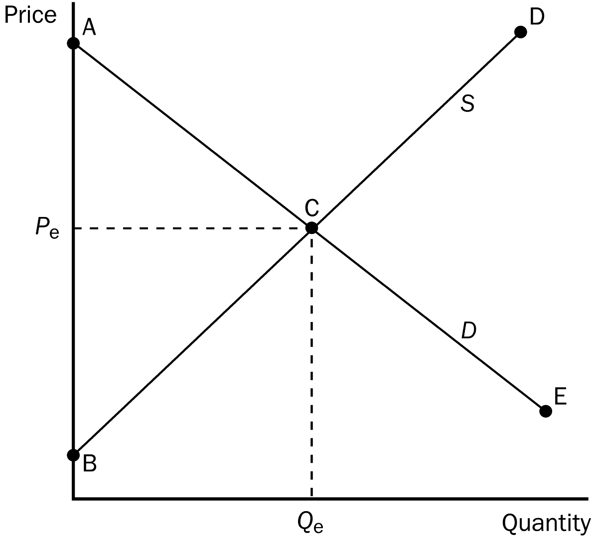
TYPE: M SECTION: 3 DIFFICULTY: 2
118. At the equilibrium price, the good will be purchased by those buyers who
a. value the good more than price.
b. value the good less than price.
c. have the money to buy the good.
d. consider the good a necessity.
ANSWER: a. value the good more than price.
TYPE: M SECTION: 3 DIFFICULTY: 2
119. According to the graph, buyers who value this good more than price are represented by segment
a. AC.
b. CE.
c. BC.
d. CD.
ANSWER: a. AC.
TYPE: M SECTION: 3 DIFFICULTY: 2
120. According to the graph, buyers who value this good less than price are represented by segment
a. AC.
b. CE.
c. BC.
d. CD.
ANSWER: b. CE.
TYPE: M SECTION: 3 DIFFICULTY: 2
121. According to the graph, sellers whose costs are less than price are represented by segment
a. AC.
b. CE.
c. BC.
d. CD.
ANSWER: c. BC.
TYPE: M SECTION: 3 DIFFICULTY: 2
122. According to the graph, sellers whose costs are greater than price are represented by segment
a. AC.
b. CE.
c. BC.
d. CD.
ANSWER: d. CD.
TYPE: M SECTION: 3 DIFFICULTY: 2
123. Given the graph, if price were higher than P_{e},
a. total surplus would fall.
b. consumer surplus would increase.
c. total surplus would rise, since producer surplus would increase.
d. consumer surplus would be greater than producer surplus.
ANSWER: a. total surplus would fall.
TYPE: M SECTION: 3 DIFFICULTY: 2
124. Total surplus in a market equals
a. Value to buyers – Amount paid by buyers.
b. Amount received by sellers – Costs of sellers.
c. Value to buyers – Costs of sellers.
d. Amount received by sellers – Amount paid by buyers.
ANSWER: c. Value to buyers – Costs of sellers.
TYPE: M SECTION: 3 DIFFICULTY: 2
125. Total surplus in a market equals
a. Consumer surplus + Producer surplus.
b. Value to buyers – Amount paid by buyers.
c. Amount received by sellers – Costs of sellers.
d. Producer surplus – Consumer surplus.
ANSWER: a. Consumer surplus + Producer surplus.
TYPE: M SECTION: 3 DIFFICULTY: 1
126. According to the graph shown, at the equilibrium price, consumer surplus would be
a. $480.
b. $640.
c. $1,120.
d. $1,280.
ANSWER: a. $480.
TYPE: M SECTION: 3 DIFFICULTY: 3
127. According to the graph shown, if the price decreases from $22 to $16, consumer surplus would increase by
a. $120.
b. $360.
c. $480.
d. $600.
ANSWER: b. $360.
TYPE: M SECTION: 3 DIFFICULTY: 3
128. According to the graph shown, at the equilibrium price, producer surplus would be
a. $480.
b. $640.
c. $1,120.
d. $1,280.
ANSWER: b. $640.
TYPE: M SECTION: 3 DIFFICULTY: 3
129. According to the graph shown, at the equilibrium price, total surplus would be
a. $480.
b. $640.
c. $1,120.
d. $1,280.
ANSWER: c. $1,120.
TYPE: M SECTION: 3 DIFFICULTY: 3
130. In the figure shown, assume demand increases and as a result, equilibrium price increases to $22 and equilibrium quantity increases to 110. The increase in producer surplus due to new producers entering the market would be equal to
a. $90.
b. $210.
c. $360.
d. $480.
ANSWER: a. $90.
TYPE: M SECTION: 3 DIFFICULTY: 3
131. In the figure shown, assume demand increases and as a result, equilibrium price increases to $22 and equilibrium quantity increases to 110. The increase in producer surplus to producers already in the market would be equal to
a. $90.
b. $210.
c. $360.
d. $480.
ANSWER: d. $480.
TYPE: M SECTION: 3 DIFFICULTY: 3
132. In the figure shown, assume demand increases and as a result, equilibrium price increases to $22 and equilibrium quantity increases to 110. The increase in total producer surplus would be equal to
a. $210.
b. $360.
c. $480.
d. $570.
ANSWER: d. $570.
TYPE: M SECTION: 3 DIFFICULTY: 3
133. According to the graph shown, the efficient price would be
a. $22 and quantity would be 40.
b. $22 and quantity would be 110.
c. $16 and quantity would be 80.
d. $8 and quantity would be 40.
ANSWER: c. $16 and quantity would be 80.
TYPE: M SECTION: 3 DIFFICULTY: 2
134. According to the graph, if this market were currently at a quantity of 110, we would know that
a. cost to sellers is equal to the value to buyers.
b. the value to buyers is greater than the cost to sellers.
c. the cost to sellers is greater than the value to buyers.
d. producer surplus would be greater than consumer surplus.
ANSWER: c. the cost to sellers is greater than the value to buyers.
TYPE: M SECTION: 3 DIFFICULTY: 3
135. According to the graph, if this market were currently at a quantity of 40, we would know that
a. cost to sellers is equal to the value to buyers.
b. the value to buyers is greater than the cost to sellers.
c. the cost to sellers is greater than the value to buyers.
d. producer surplus would be greater than consumer surplus.
ANSWER: b. the value to buyers is greater than the cost to sellers.
TYPE: M SECTION: 3 DIFFICULTY: 3
136. An allocation of resources is said to be inefficient if
a. a good is not being produced by the sellers with the lowest cost.
b. producer surplus is not at a minimum.
c. consumer surplus is not at a maximum.
d. All of the above are correct.
ANSWER: a. a good is not being produced by the sellers with the lowest cost.
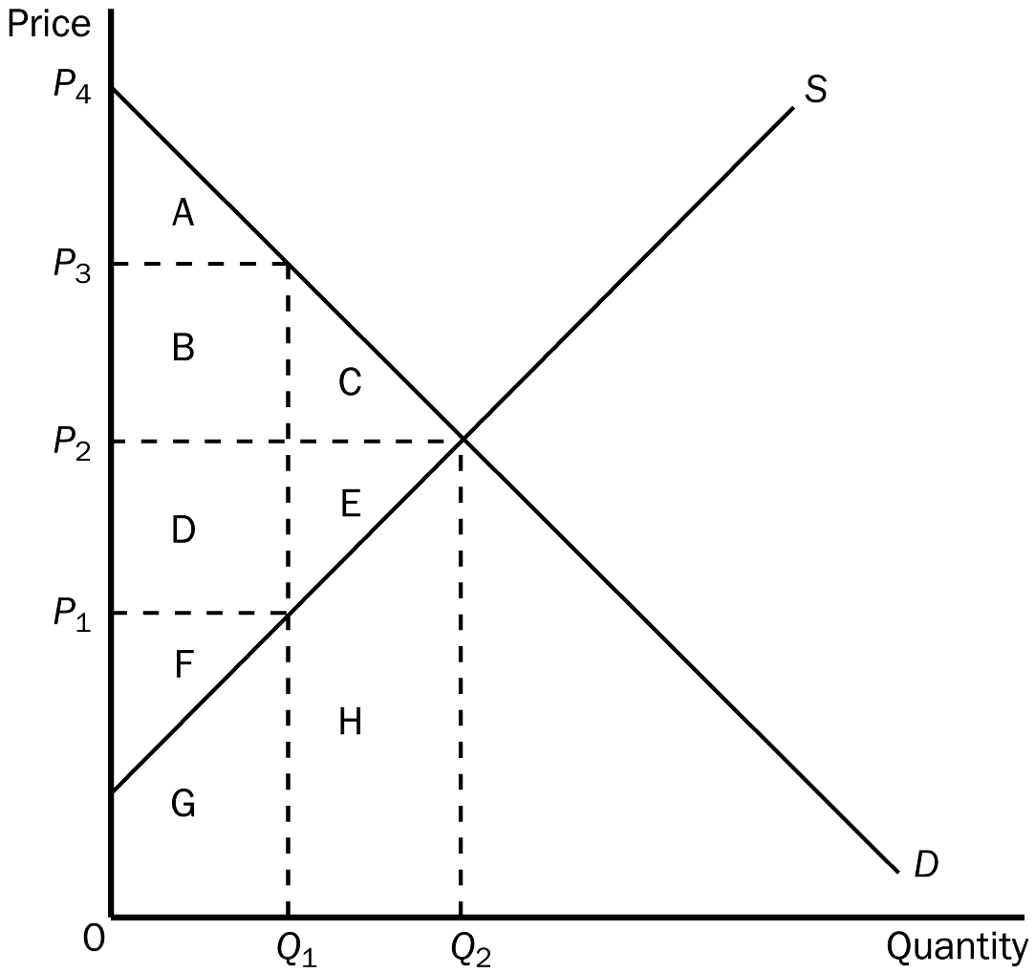
TYPE: M SECTION: 3 DIFFICULTY: 1
137. According to the graph shown, the equilibrium (market-clearing) price is
a. P₁.
b. P₂.
c. P₃.
d. P₄.
ANSWER: b. P₂.
TYPE: M SECTION: 3 DIFFICULTY: 1
138. According to the graph shown, at the market-clearing equilibrium, total consumer surplus is represented by the area
a. A.
b. A + B + C.
c. D + E + F.
d. A + B + C + D + E + F.
ANSWER: b. A + B + C.
TYPE: M SECTION: 3 DIFFICULTY: 2
139. According to the graph shown, at the market-clearing equilibrium, total producer surplus is represented by the area
a. F.
b. F + G.
c. D + E + F.
d. D + E + F + G + H.
ANSWER: c. D + E + F.
TYPE: M SECTION: 3 DIFFICULTY: 2
140. According to the graph shown, at the market-clearing equilibrium, total surplus is represented by the area
a. A + B + C.
b. A + B + D + F.
c. A + B + C + D + E + F.
d. A + B + C + D + E + F + G + H.
ANSWER: c. A + B + C + D + E + F.
TYPE: M SECTION: 3 DIFFICULTY: 2
141. According to the graph shown, the efficient price-quantity combination is
a. P₁ and Q₁.
b. P₂ and Q₂.
c. P₃ and Q₁.
d. P₄ and 0.
ANSWER: b. P₂ and Q₂.
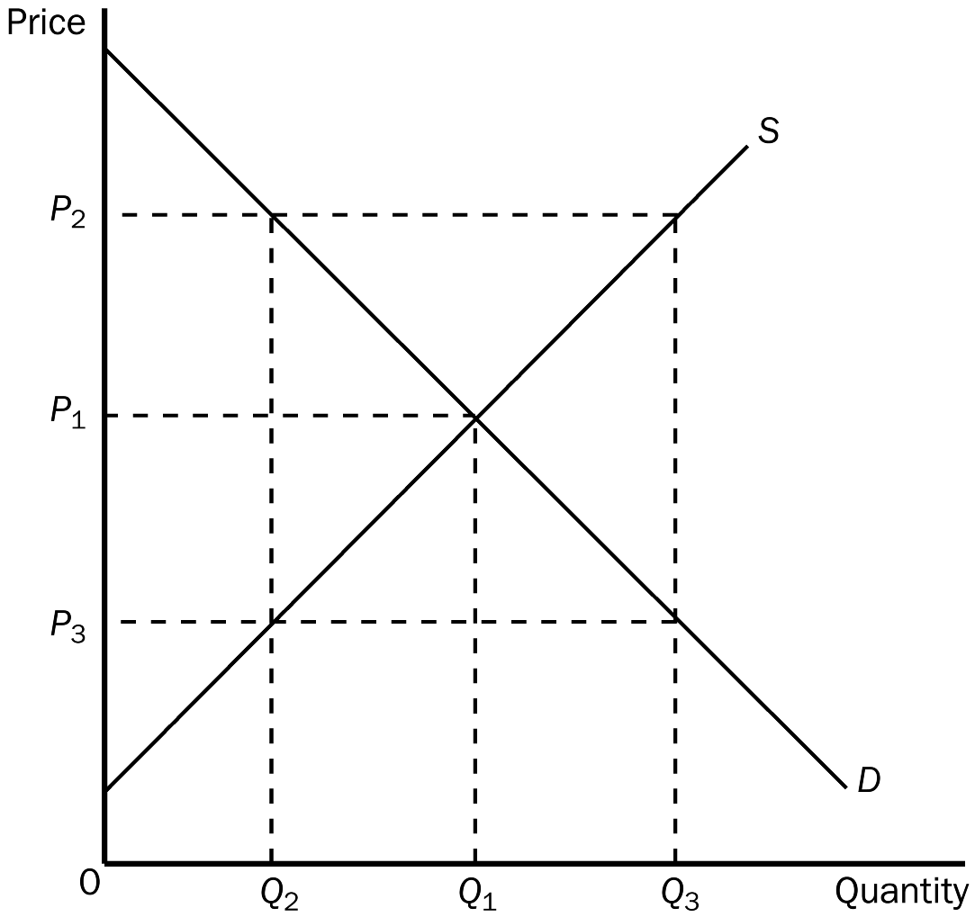
TYPE: M SECTION: 3 DIFFICULTY: 1
142. According to the graph shown, at the quantity Q₂,
a. the market is in equilibrium.
b. the value to buyers is greater than the cost to sellers.
c. consumer surplus plus producer surplus is maximized.
d. the value to buyers is less than the cost to sellers.
ANSWER: b. the value to buyers is greater than the cost to sellers.
TYPE: M SECTION: 3 DIFFICULTY: 2
143. According to the graph shown, for the quantity Q₃, the value to buyers
a. and the cost to sellers are both P₂.
b. is P₁ and the cost to sellers is P₃.
c. and the cost to sellers are both P₃.
d. is P₃ and the cost to sellers is P₂.
ANSWER: d. is P₃ and the cost to sellers is P₂.
TYPE: M SECTION: 3 DIFFICULTY:2
144. When a market is in equilibrium, which of the following would not be correct?
a. The price determines which buyers and sellers participate in the market.
b. Those buyers who value the good more than the price choose to buy the good.
c. Those sellers whose costs are less than the price choose to produce and sell the good.
d. Consumer surplus will be equal to producer surplus.
ANSWER: d. Consumer surplus will be equal to producer surplus.
TYPE: M SECTION: 3 DIFFICULTY:2
145. When economists say that markets are efficient, they are assuming that markets are
a. perfectly competitive.
b. not for illegal products.
c. regulated by the government.
d. monopolistic.
ANSWER: a. perfectly competitive.
TYPE: M SECTION: 3 DIFFICULTY:1
146. Inefficiency can be caused in a market by the presence of
a. market power.
b. externalities.
c. profiteering.
d. All of the above are correct.
e. Both a and b are correct.
ANSWER: e. Both a and b are correct.
TYPE: M SECTION: 3 DIFFICULTY:2
147. Efficiency occurs when
a. total surplus is maximized.
b. producer surplus is maximized.
c. all resources are being used.
d. consumer surplus equals producer surplus.
ANSWER: a. total surplus is maximized.
TYPE: M SECTION: 3 DIFFICULTY:1
148. Moving production from a high-cost producer to a low-cost producer will
a. lower total surplus.
b. raise total surplus.
c. lower producer surplus.
d. raise producer surplus but lower consumer surplus.
ANSWER: b. raise total surplus.
TYPE: M SECTION: 3 DIFFICULTY: 2
149. Inefficiency exists in any economy when a good is
a. not being consumed by buyers who value it most highly.
b. not distributed fairly among buyers.
c. not being produced by the highest-cost producer.
d. being produced with less than all available resources.
ANSWER: a. not being consumed by buyers who value it most highly.
TYPE: M SECTION: 3 DIFFICULTY:2
150. Inefficiency exists in an economy when a good is
a. being produced with less than all available resources.
b. not distributed fairly among buyers.
c. not being produced by the lowest-cost producers.
d. being consumed by buyers who value it most highly.
ANSWER: c. not being produced by the lowest-cost producers.
TYPE: M SECTION: 3 DIFFICULTY:2
151. Which of the following is correct?
a. Efficiency deals with the size of the economic pie and equity deals with how fairly the pie is sliced.
b. Equity can be judged on positive grounds where efficiency requires normative judgments.
c. Efficiency is more difficult to evaluate than equity.
d. Equity and efficiency are both maximized in a society when total surplus is maximized.
ANSWER: a. Efficiency deals with the size of the economic pie and equity deals with how fairly the pie is sliced.
TYPE: M SECTION: 3 DIFFICULTY:2
152. If the government allowed a free market for transplant organs (such as kidneys) to exist
a. the shortage of organs would be eliminated.
b. those with the greatest need would be first to receive an organ.
c. organs would be distributed more fairly.
d. only the very rich in a society would receive a transplant.
ANSWER: a. the shortage of organs would be eliminated.
TYPE: M SECTION: 3 DIFFICULTY:2
153. The “invisible hand” refers to
a. the marketplace guiding the self-interests of market participants into promoting general economic well-being.
b. the marketplace as a place where government looks out for the interests of individual participants in the market.
c. the equity that results from market forces allocating the goods produced in the market.
d. the automatic maximization of consumer surplus in free markets.
ANSWER: a. the marketplace guiding the self-interests of market participants into promoting general economic well-being.
TYPE: M SECTION: 3 DIFFICULTY:2
154. The “invisible hand” is
a. used to describe the welfare system in the United States.
b. a concept used by Adam Smith to describe the virtues of free markets.
c. a concept used by J.M. Keynes to describe the role of government in guiding the allocation of resources in the economy.
d. a term used by some economists to describe what the role of government should be in an economy—present but invisible.
ANSWER: b. a concept used by Adam Smith to describe the virtues of free markets.
TYPE: M SECTION: 3 DIFFICULTY:1
155. Economists tend to see ticket scalping as
a. a way for a few to profit while producing nothing of value.
b. an inequitable interference in the orderly process of ticket distribution.
c. a way of increasing the efficiency of ticket distribution.
d. an unproductive activity which should be made illegal everywhere.
ANSWER: c. a way of increasing the efficiency of ticket distribution.
TYPE: M SECTION: 3 DIFFICULTY:2
156. “Laissez-faire” is a French expression which literally means
a. to make do.
b. to get involved.
c. whatever works.
d. allow them to do.
ANSWER: d. allow them to do.
TYPE: M SECTION: 3 DIFFICULTY:1
157. The French expression used to express the free market concept which literally translates “allow them to do” is
b. laissez-faire.
c. je ne sais pas.
d. si’l vous plait.
e. tête-à-tête.
ANSWER: a. laissez-faire.
TYPE: M SECTION: 3 DIFFICULTY:1
158. According to many economists, government restrictions of ticket scalping do all of the following EXCEPT
a. inconvenience the public.
b. reduce the audience for cultural and sports events.
c. waste the police’s time.
d. keep the cost of tickets to consumers low.
ANSWER: d. keep the cost of tickets to consumers low.
TYPE: M SECTION: 3 DIFFICULTY:2
159. Many economists believe that restrictions against ticket scalping will cause each of the following EXCEPT
a. smaller audiences for cultural and sporting events.
b. less tax revenue for the state.
c. an increase in ticket prices.
d. fewer cultural and sporting events planned.
ANSWER: d. fewer cultural and sporting events planned.
TYPE: M SECTION: 3 DIFFICULTY:2
160. Market power refers to the
a. side effects that may occur in a market.
b. government regulations imposed on the sellers in a market.
c. ability to influence price.
d. forces of supply and demand in determining equilibrium price.
ANSWER: c. ability to influence price.
TYPE: M SECTION: 4 DIFFICULTY:1
161. Externalities are
a. side effects passed on to a party other than the buyers and sellers in the market.
b. external forces that help establish equilibrium price.
c. external forces that cause the price of a good to be higher than it otherwise would be.
d. side effects of government intervention in markets.
ANSWER: a. side effects passed on to a party other than the buyers and sellers in the market.
TYPE: M SECTION: 4 DIFFICULTY:1
162. The decisions of buyers and sellers that affect people who are not participants in the market create
a. market power.
b. externalities.
c. profiteering.
d. market equilibrium.
ANSWER: b. externalities.
TYPE: M SECTION: 4 DIFFICULTY:1
163. Which of the following would NOT show an inefficient market?
a. A scalper selling Kansas City Chiefs football tickets on the sidewalk.
b. The only gas station in a location that is 100 miles from the next closest gas station.
c. A steel mill that also produces pollution.
d. A college student attending a private university.
ANSWER: a . A scalper selling Kansas City Chiefs football tickets on the sidewalk.
TYPE: M SECTION: 4 DIFFICULTY: 2
164. Market failure is the inability of
a. buyers to interact harmoniously with sellers in the market.
b. a market to establish an equilibrium price.
c. buyers to place a value on the good or service.
d. some unregulated markets to allocate resources efficiently.
ANSWER: d. some unregulated markets to allocate resources efficiently.
TYPE: M SECTION: 4 DIFFICULTY:2
165. When markets fail, public policy
a. can do nothing to improve the situation.
b. can potentially remedy the problem and increase economic efficiency.
c. can always remedy the problem and increase economic efficiency.
d. can, in theory, remedy the problem, but in practice, has proven to be ineffective.
ANSWER: b. can potentially remedy the problem and increase economic efficiency.
TYPE: M SECTION: 4 DIFFICULTY:2
166. Suppose that the equilibrium price in the market for widgets is $5. If a law reduced the maximum legal price for widgets to $4,
a. consumer surplus would necessarily increase even if the lower price resulted in a shortage of widgets.
b. consumer surplus would necessarily decrease because the lower price would create a shortage of widgets.
c. consumer surplus might increase or decrease.
d. consumer surplus would be unaffected.
ANSWER: c. consumer surplus might increase or decrease.
TYPE: M SECTION: 3 DIFFICULTY: 3
167. Suppose that the equilibrium price in the market for widgets is $5. If a law increased the minimum legal price for widgets to $6, producer surplus
a. would necessarily increase even if the higher price resulted in a surplus of widgets.
b. would necessarily decrease because the higher price would create a surplus of widgets.
c. might increase or decrease.
d. would be unaffected.
ANSWER: c. might increase or decrease.
TYPE: M SECTION: 3 DIFFICULTY: 3
168. Suppose that the equilibrium price in the market for widgets is $5. If a law reduced the maximum legal price for widgets to $4,
a. any possible increase in consumer surplus would be larger than the loss of producer surplus.
b. any possible increase in consumer surplus would be smaller than the loss of producer surplus.
c. the resulting increase in producer surplus would be larger than any possible loss of consumer surplus.
d. the resulting increase in producer surplus would be smaller than any possible loss of consumer surplus.
ANSWER: b. any possible increase in consumer surplus would be smaller than the loss of producer surplus.
TYPE: M SECTION: 3 DIFFICULTY: 3
169. Suppose that the equilibrium price in the market for widgets is $5. If a law increased the minimum legal price for widgets to $6,
a. the resulting increase in consumer surplus would be larger than any possible loss of producer surplus.
b. the resulting increase in consumer surplus would be smaller than any possible loss of producer surplus.
c. any possible increase in producer surplus would be larger than the loss of consumer surplus.
d. any possible increase in producer surplus would be smaller than the loss of consumer surplus.
ANSWER: d. any possible increase in producer surplus would be smaller than the loss of consumer surplus.
TYPE: M SECTION: 3 DIFFICULTY: 3
170. At present, the maximum legal price for a human kidney is $0. The price of $0 maximizes
a. consumer surplus, but not producer surplus.
b. producer surplus, but not consumer surplus.
c. both consumer and producer surplus.
d. neither consumer nor producer surplus.
ANSWER: d. neither consumer nor producer surplus.
TYPE: M SECTION: 3 DIFFICULTY: 3
171. If a market is allowed to move freely to its equilibrium price and quantity, then an increase in demand will
a. increase producer surplus.
b. reduce producer surplus.
c. not affect producer surplus.
d. possibly increase, decrease or not affect producer surplus.
ANSWER: a. increase producer surplus.
TYPE: M SECTION: 3 DIFFICULTY: 2
172. If a market is allowed to move freely to its equilibrium price and quantity, then an increase in supply will
a. increase consumer surplus.
b. reduce consumer surplus.
c. not affect consumer surplus.
d. possibly increase, decrease or not affect consumer surplus.
ANSWER: a. increase consumer surplus.
TYPE: M SECTION: 3 DIFFICULTY: 2
173. A simultaneous increase in both the demand for and the supply of radios would imply that
a. both the value of radios to consumers and the cost of producing radios has increased.
b. both the value of radios to consumers and the cost of producing radios has decreased.
c. the value of radios to consumers has decreased and the cost of producing radios has increased.
d. the value of radios to consumers has increased and the cost of producing radios has decreased.
ANSWER: d. the value of radios to consumers has increased and the cost of producing radios has decreased.
TYPE: M SECTION: 3 DIFFICULTY: 2
174. Cornflakes and milk are complementary goods. A decrease in the price of corn would
a. increase consumer surplus in the market for cornflakes but decrease producer surplus in the market for milk.
b. increase consumer surplus in the market for cornflakes and increase producer surplus in the market for milk.
c. decrease consumer surplus in the market for cornflakes but increase producer surplus in the market for milk.
d. decrease consumer surplus in the market for cornflakes and decrease producer surplus in the market for milk.
ANSWER: b. increase consumer surplus in the market for cornflakes and increase producer surplus in the market for milk.
TYPE: M SECTION: 3 DIFFICULTY: 3
175. Orange juice and apple juice are substitutes. Bad weather that sharply reduced the orange harvest would
a. increase consumer surplus in the market for orange juice but decrease producer surplus in the market for apple juice.
b. increase consumer surplus in the market for orange juice and increase producer surplus in the market for apple juice.
c. decrease consumer surplus in the market for orange juice but increase producer surplus in the market for apple juice.
d. decrease consumer surplus in the market for orange juice and decrease producer surplus in the market for apple juice.
ANSWER: c. decrease consumer surplus in the market for orange juice but increase producer surplus in the market for apple juice.
TYPE: M SECTION: 3 DIFFICULTY: 3
176. A technological advance in the production of computers will
a. increase consumer surplus in the market for computers and decrease producer surplus in the market for computer software.
b. increase consumer surplus in the market for computers and increase producer surplus in the market for computer software.
c. decrease consumer surplus in the market for computers but increase producer surplus in the market for computer software.
d. decrease consumer surplus in the market for computers and decrease producer surplus in the market for computer software.
ANSWER: b. increase consumer surplus in the market for computers and increase producer surplus in the market for computer software.
TYPE: M SECTION: 3 DIFFICULTY: 3
TRUE/FALSE
1. Welfare economics is the study of the welfare system.
ANSWER: F TYPE: T
2. The equilibrium of supply and demand in a market maximizes the total benefits received by buyers and sellers.
ANSWER: T TYPE: T
3. The willingness to pay is the maximum amount that a buyer will pay for a good and measures how much the buyer values the good.
ANSWER: T TYPE: T SECTION 1
4. Consumer surplus is the amount a buyer actually has to pay for a good minus the amount the buyer is willing to pay for it.
ANSWER: F TYPE: T SECTION 1
5. Joel has a 1966 Mustang, which he sells to Susie, an avid car collector. Susie is pleased since she paid $8,000 for the car but would have been willing to pay $11,000 for the car. Susie’s consumer surplus is $2,000.
ANSWER: F TYPE: T SECTION: 1
6. For any given quantity, the price on a demand curve represents the marginal buyer’s willingness to pay.
ANSWER: T TYPE: T SECTION: 1
7. The area above the demand curve and below the price measures the consumer surplus in a market.
ANSWER: F TYPE: T SECTION: 1
8. Consumer surplus measures the benefit to buyers of participating in a market.
ANSWER: T TYPE: T SECTION: 1
9. A buyer is willing to buy a product at a price greater than or equal to his willingness to pay, but would refuse to buy a product at a price less than his willingness to pay.
ANSWER: F TYPE: T SECTION: 1
10. Each seller of a product is willing to sell as long as the price he or she can receive is greater than the opportunity cost of producing the product.
ANSWER: T TYPE: T SECTION: 2
11. In a competitive market, sales go to those producers who are willing to supply the product at the lowest price.
ANSWER: T TYPE: T SECTION: 2
12. Producer surplus is the amount a seller is paid minus the cost of production.
ANSWER: T TYPE: T SECTION: 2
13. Connie can clean windows in large office buildings at a cost of $1 per window. The market price for window cleaning is $3 per window. If Connie cleans 100 windows, her producer surplus is $100.
ANSWER: F TYPE: T SECTION: 2
14. At any quantity, the price given by the supply curve shows the cost of the lowest-cost seller.
ANSWER: F TYPE: T SECTION: 2
15. The area below the price and above the supply curve measures the producer surplus in a market.
ANSWER: T TYPE: T SECTION: 2
16. When market price increases, producer surplus increases because (1) producer surplus received by existing sellers increases, and (2) new sellers enter the market.
ANSWER: T TYPE: T SECTION: 2
17. Total surplus in a market is consumer surplus minus producer surplus.
ANSWER: F TYPE: T SECTION: 2
18. Total surplus = Value to buyers – Costs to sellers.
ANSWER: T TYPE: T SECTION: 2
19. Efficiency refers to whether a market outcome is fair, while equity refers to whether the maximum amount of output was produced from a given number of inputs.
ANSWER: F TYPE: T SECTION: 2
20. Efficiency is related to the size of the economic pie, where equity is related to how the pie gets sliced and distributed.
ANSWER: T TYPE: T SECTION: 2
21. Total surplus in a market can be measured as the area below the supply curve and the area above the demand curve.
ANSWER: F TYPE: T SECTION: 2
22. Free markets allocate (1) the supply of goods to the buyers who value them most highly and (2) the demand for goods to the sellers who can produce them at least cost.
ANSWER: T TYPE: T SECTION: 2
23. Even though participants in the economy are motivated by self-interest, the “invisible hand” of the marketplace guides this self-interest into promoting general economic well-being.
ANSWER: T TYPE: T SECTION: 2
24. Economists generally believe that although there may be advantages to society from ticket-scalping, the costs to society of this activity outweigh the benefits.
ANSWER: F TYPE: T KEY1: D SECTION: 2 OBJECTIVE: 4 RANDOM: Y
25. Restrictions against ticket scalping actually drive up the cost of many tickets.
ANSWER: T TYPE: T SECTION: 2
26. If the United States allowed a legal market to exist in transplant organs, it is estimated that one kidney would sell for at least $100,000.
ANSWER: F TYPE: T SECTION: 2
27. The primary factor in saving the Pilgrims from certain starvation was their ability to trade freely with the Native Americans.
ANSWER: F TYPE: T SECTION: 2
28. In order for market outcomes to maximize the total benefits to buyers and sellers, the markets must be perfectly competitive.
ANSWER: T TYPE: T SECTION: 3
29. When markets fail, public policy can potentially remedy the problem and increase economic efficiency.
ANSWER: T TYPE: T SECTION: 4
SHORT ANSWER
1. Answer each of the following questions on demand and consumer surplus.
a. What is consumer surplus, and how is it measured?
b. What is the relationship between the demand curve and the willingness to pay?
c. Other things equal, what happens to consumer surplus if the price of a good falls? Why? Illustrate using a demand curve.
d. In what way does the demand curve represent the benefit consumers receive from participating in a market? In addition to the demand curve, what else must be considered to determine consumer surplus?
ANSWER:
a. Consumer surplus measures the benefit to buyers of participating in a market. It is measured as the amount a buyer is willing to pay for a good minus the amount a buyer actually pays for it. For an individual purchase, consumer surplus is the difference between the willingness to pay, as shown on the demand curve, and the market price. For the market, total consumer surplus is the area under the demand curve and above the price, from the origin to the quantity purchased.
b. Because the demand curve shows the maximum amount buyers are willing to pay for a given market quantity, the price given by the demand curve represents the willingness to pay of the marginal buyer.
c. When the price of a good falls, consumer surplus increases for two reasons. First, those buyers who were already buying the good receive an increase in consumer surplus because they are paying less (area B). Second, some new buyers enter the market because the price of the good is now lower than their willingness to pay (area C); hence, there is additional consumer surplus generated from their purchases. The graph should show that as price falls from P2 to P1, consumer surplus increases from area A to area A + B + C.
d. Since the demand curve represents the maximum price the marginal buyer is willing to pay for a good, it must also represent the maximum benefit the buyer expects to receive from consuming the good. Consumer surplus must take into account the amount the buyer actually pays for the good, with consumer surplus measured as the difference between what the buyer is willing to pay and what he/she actually paid. Consumer surplus, then, measures the benefit the buyer didn’t have to “pay for.”
TYPE: S SECTION: 1
2. Tammy loves donuts. The table shown reflects the value Tammy places on each donut she eats:

VALUE OF FIRST DONUT | 60¢
VALUE OF SECOND DONUT | $0.50
VALUE OF THIRD DONUT | $0.40
VALUE OF FOURTH DONUT | $0.30
VALUE OF FIFTH DONUT | $0.20¢
VALUE OF SIXTH DONUT | $0.10

a. Use this information to construct Tammy’s demand curve for donuts.
b. If the price of donuts is $0.20, how many donuts will Tammy buy?
c. Show Tammy’s consumer surplus on your graph. How much consumer surplus would she have at a price of $0.20?
d. If the price of donuts rose to $0.40, how many donuts would she purchase now? What would happen to Tammy’s consumer surplus? Show this change on your graph.
ANSWER:
a. 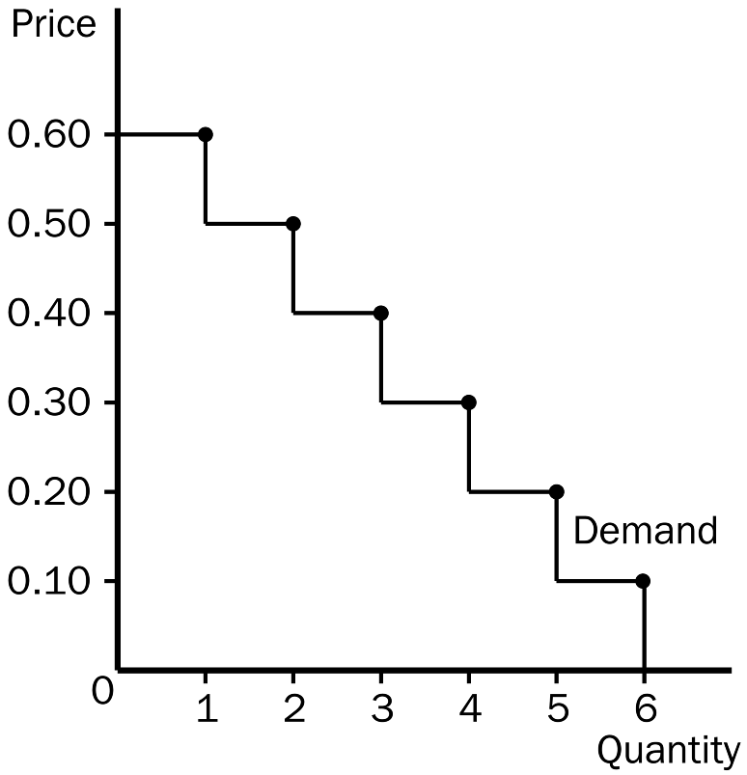
b. At a price of $0.20, Tammy would buy 5 donuts.
c. The figure below shows Tammy’s consumer surplus. At a price of $0.20, Tammy’s consumer surplus would be $1.00.
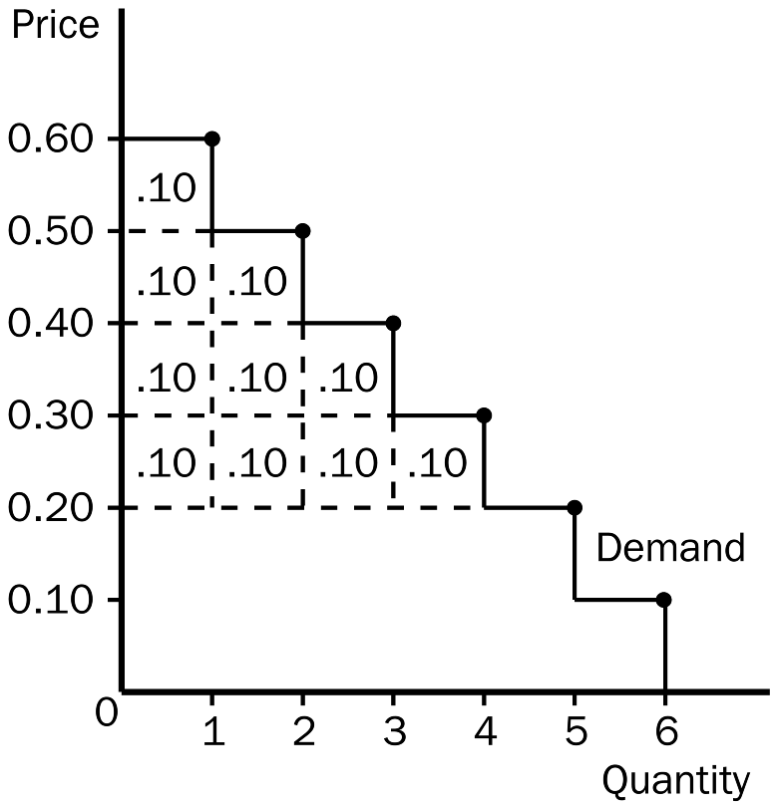
d. If the price of donuts rose to $0.40, Tammy’s consumer surplus would fall to $0.30 and she would purchase only 3 donuts.
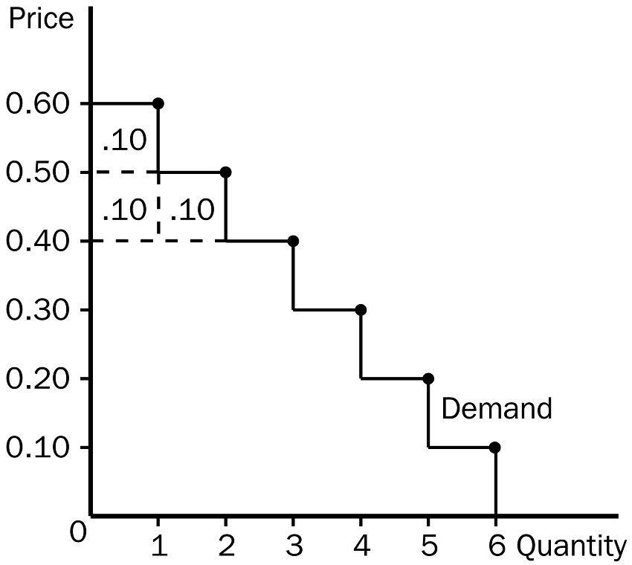
TYPE: S SECTION: 1
3. Answer each of the following questions on supply and producer surplus.
a. What is producer surplus, and how is it measured?
b. What is the relationship between the cost to sellers and the supply curve?
c. Other things equal, what happens to producer surplus when the price of a good rises? Illustrate your answer on a supply curve.
ANSWER:
a. Producer surplus measures the benefit to sellers of participating in a market. It is measured as the amount a seller is paid minus the cost of production. For an individual sale, producer surplus is measured as the difference between the market price and the cost of production, as shown on the supply curve. For the market, total producer surplus is measured as the area above the supply curve and below the market price, between the origin and the quantity sold.
b. Because the supply curve shows the minimum amount sellers are willing to accept for a given quantity, the supply curve represents the cost of the marginal seller.
c. When the price of a good rises, producer surplus increases for two reasons. First, those sellers who were already selling the good have an increase in producer surplus because the price they receive is higher (area A). Second, new sellers will enter the market because the price of the good is now higher than their willingness to sell (area B); hence, there is additional producer surplus generated from their sales. The graph should show that as price rises from P1 to P2, producer surplus increases from area C to area A + B + C.
TYPE: S SECTION: 2
4. Given the following equations two equations:
1) Total Surplus = Consumer Surplus + Producer Surplus
2) Total Surplus = Value to Buyers – Cost to Sellers
Show how equation (1) can be used to derive equation (2).
ANSWER: Start with the equation: Total Surplus = Consumer Surplus + Producer Surplus. Then, since Consumer Surplus = Value to buyers – Amount paid by buyers, and since Producer Surplus = Amount received by sellers – Costs of sellers, then Total Surplus can be written as: Value to buyers – Amount paid by buyers + Amount received by sellers – Costs of sellers. Since the Amount paid by buyers equals the Amount received by sellers, the middle two terms cancel out and the result is:
Total Surplus = Value to buyers – Costs of sellers.
TYPE: S SECTION: 3
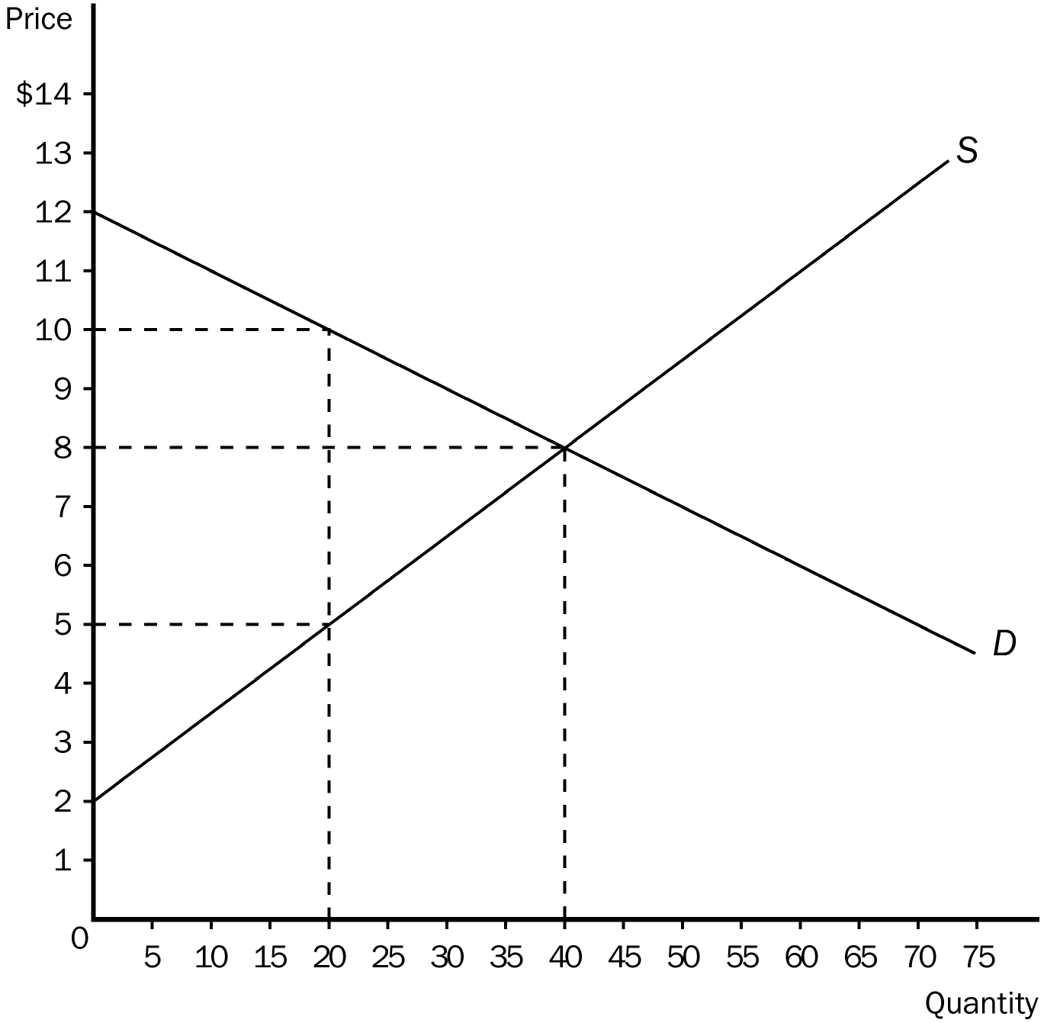
5. Answer the following questions based on the graph that represents JR’s demand for ribs per week of ribs at Judy’s rib shack.

a. At equilibrium price, how many ribs would JR be willing to purchase?
b. How much is JR willing to pay for 20 ribs?
c. How much would JR’s consumer surplus be at the equilibrium price?
d. At the equilibrium price, how many ribs would Judy be willing to sell?
e. How much must the price of ribs be for Judy to supply 20 ribs to the market?
f. At the equilibrium price, what is total surplus in the market?
g. If the price of ribs rose to $10, what would happen to JR’s consumer surplus?
h. If the price of ribs fell to $5, what would happen to Judy’s producer surplus?
i. Explain why the graph shown verifies the fact that the market equilibrium (quantity) maximizes the sum of producer and consumer surplus.
ANSWER:
a. 40
b. $10.00
c. $80.00.
d. 40
e. $5
f. $200
g. It would fall from $80 to only $20.
h. It would fall from $120 to only $30.
i. At quantities less than the equilibrium quantity, the value to buyers exceeds the cost to sellers. Increasing the quantity in this region raises total surplus until equilibrium quantity is reached. At quantities greater than the equilibrium quantity, the cost to sellers exceeds the value to buyers and total surplus falls.
TYPE: S SECTION: 3

